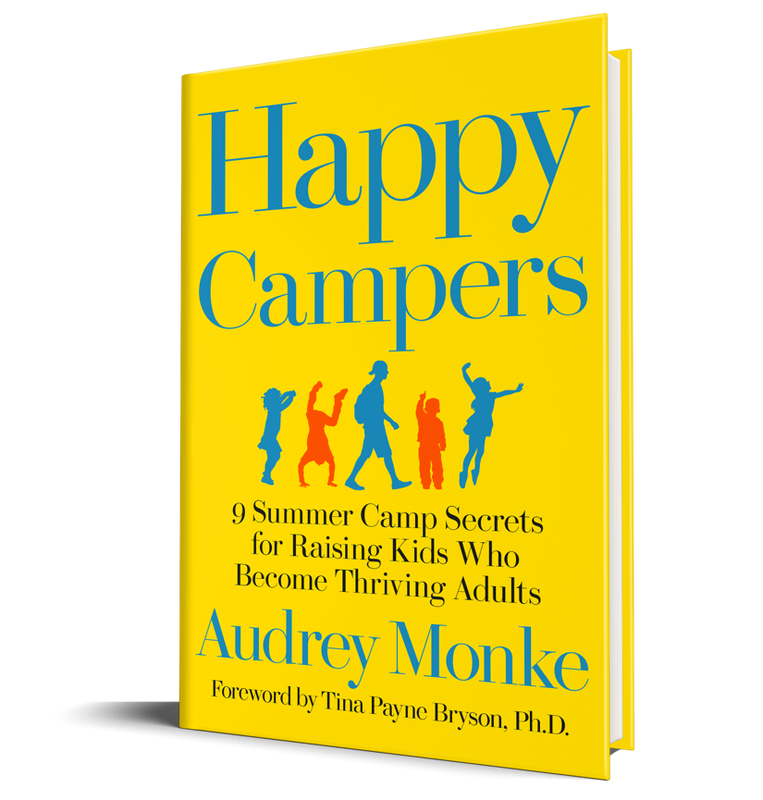
Happy Campers:
9 Summer Camp Secrets for Raising Kids Who Become Thriving Adults

Happy Campers – full of practical and powerful tools that parents can immediately put into practice – lights a path to help parents nurture a culture of connection in our homes…to help our children become their best selves.

-Tina Payne Bryson, Ph.D., LCSW, and NYT bestelling co-author of The Whole Brain Child

Why are kids more optimistic, resilient, independent, and competent after just a few weeks at summer camp?
Why do they feel less depressed, anxious, and disconnected at camp than they do anywhere else?
Why do so many campers call camp their “happy place” and feel so heartbroken when it’s time to go home?
Veteran summer camp director and parent of five Audrey Monke shares what she’s learned from three decades of creating a culture where kids become happier while gaining important social and emotional skills in just two weeks.
Based on thousands of interactions with campers, camp counselors, and parents, academic research in positive psychology, and interviews with camp directors from across the country, HAPPY CAMPERS introduces a framework of intentional strategies to help parents create the same kind of transformational culture that kids experience at camp. Instead of raising kids who are overwhelmed, anxious, depressed, and unable to function as independent and responsible adults, parents can create an environment at home that promotes the growth of important character traits and social skills that kids need in order to have meaningful and successful lives. Complete with specific ideas to implement these summer camp secrets at home, HAPPY CAMPERS is a one-of-a-kind resource for parents wanting to raise happy, socially intelligent, successful kids.

Praise for Happy Campers

"Happy Campers offers the big dose of positivity parents need! Make your parenting far more enjoyable and effective by adopting practices camp counselors use at summer camp to create fun, life-changing, and character-building experiences for their campers. The 'Bringing Camp Home' section at the end of each chapter provides proven ideas and practices to raise kids who are more capable, kind, resilient, and optimistic - and who have the skills to thrive as adults!"
-Jon Gordon, best selling author of The Energy Bus and The Power of a Positive Team

"Happy Campers is a remarkably powerful parenting guide. Audrey brings a unique confluence of skills. She has been a camp director for over three decades and has worked with thousands of children and their parents. She has seen what produces capable and content children - and what produces the opposite. She combines that experience with a deep understanding of psychology and her own experience as a mother of five. In Happy Campers, Audrey shares a wealth of knowledge coupled with truly practical advice. The unexpected benefit is that her advice actually makes being a parent more enjoyable as well as more effective!"
-Steve Baskin, Owner/Director of Camp Champions, Psychology Today writer, and TEDx Speaker

"The amazing benefits of camp can be nurtured beyond the summer months. This wonderful book puts it right in your hands."
-Brooke Cheley-Klebe, Owner/Director of Cheley Colorado Camps
"Audrey has taken her many years of experience as an educator, researcher, camp owner and parent and distilled what she has learned into some very practical and impactful lessons that parents can use to create happier, stronger children and families. I have taken lessons from Happy Campers and applied them to my camp and my parenting."
-Jeff Gamble, Owner/Director of Jefunira Camp

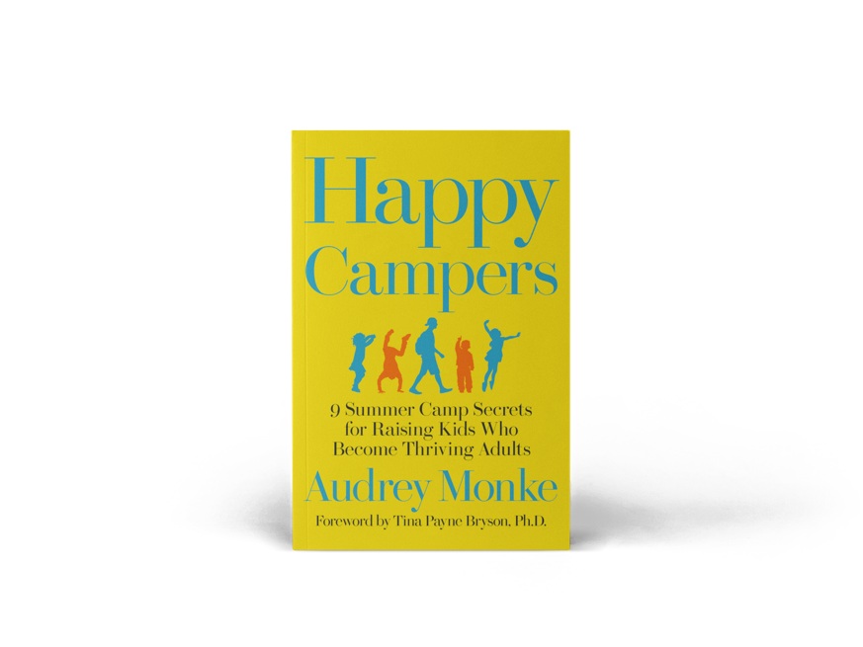
Social

Website: sunshine-parenting.com
Facebook: /sunshineparenting
Twitter: /audreymonke
Pinterest: /gacsunshine
Instagram: /sunshine.parenting

Pre-order now for delivery on May 7, 2019.

